SETUP

DROP DATABASE project_db;

CREATE DATABASE project_db;
USE project_db;

SCHEMA CREATION

-- Create Department table
CREATE TABLE Department (
DeptID INT PRIMARY KEY AUTO_INCREMENT,
DeptName VARCHAR(255),
ManagerID INT
);

-- Create Employee table
CREATE TABLE Employee (
EmplD INT PRIMARY KEY,
Name VARCHAR(255),
DeptID INT,
Salary INT,
Experience VARCHAR(255),
FOREIGN KEY (DeptID) REFERENCES Department(DeptID)
);

-- Create Project table
CREATE TABLE Project (
ProjectID INT PRIMARY KEY,
ProjectName VARCHAR(255),
DeptID INT,
Budget INT,
FOREIGN KEY (DeptID) REFERENCES Department(DeptID)
);
-- Create Works_On table
CREATE TABLE Works_On (
EmplD INT,
ProjectID INT,
HoursWorked INT,
PRIMARY KEY (EmplD, ProjectID),
FOREIGN KEY (EmplD) REFERENCES Employee(EmplD),
FOREIGN KEY (ProjectID) REFERENCES Project(ProjectID)
);
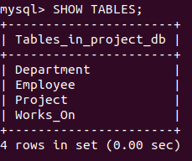

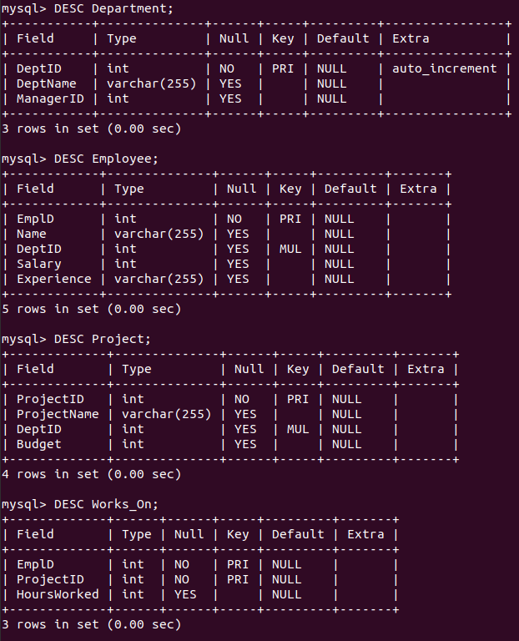
DATA INSERTION

-- Inserting data into the Department table
INSERT INTO Department (DeptName, ManagerID) VALUES
('HR', 201),
('IT', 202),
('Finance', 203);

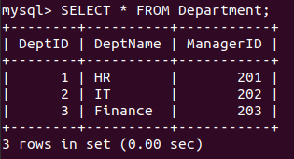

-- Inserting data into the Employee table
INSERT INTO Employee (EmplD, Name, DeptID, Salary, Experience) VALUES
(101, 'Alice', 1, 50000, '5 years'),
(102, 'Bob', 2, 70000, '7 years'),
(103, 'Carol', 1, 65000, '6 years'),
(104, 'David', 3, 72000, '8 years'),
(105, 'Eve', 2, 52000, '64 years');

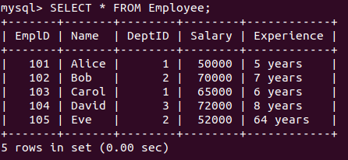

-- Inserting data into the Project table
INSERT INTO Project (ProjectID, ProjectName, DeptID, Budget) VALUES
(501, 'Alpha', 1, 500000),
(502, 'Beta', 2, 700000),
(503, 'Gamma', 1, 650000),
(504, 'Delta', 3, 720000);

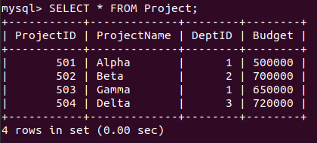

-- Inserting data into the Works_On table
INSERT INTO Works_On (EmplD, ProjectID, HoursWorked) VALUES
(101, 501, 30),
(102, 502, 25),
(103, 503, 20),
(104, 504, 35),
(105, 502, 28);

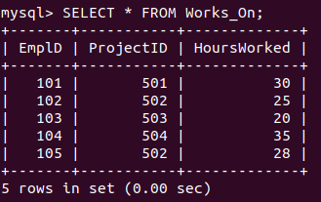

NESTED QUERIES

Q1)
SELECT DISTINCT DeptName
FROM Department
WHERE DeptID IN (
SELECT DeptID FROM Employee
WHERE Salary > 60000
);

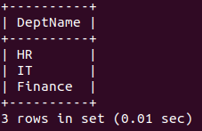

Q2)
SELECT emp.Name
FROM Employee emp
WHERE EXISTS (
SELECT * FROM Project proj
JOIN Works_On worksOn ON proj.ProjectID = worksOn.ProjectID
WHERE worksOn.EmplD = emp.EmplD AND proj.DeptID = emp.DeptID
);

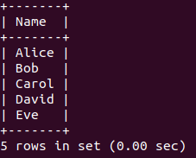

Q3)
SELECT DeptName
FROM Department dept
WHERE NOT EXISTS (
SELECT * FROM Employee emp
WHERE emp.DeptID = dept.DeptID AND emp.Salary <= (
SELECT AVG(Salary)
FROM Employee
)
);

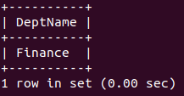

Q4)
SELECT emp.Name
FROM Employee emp
WHERE NOT EXISTS (
SELECT proj.ProjectID
FROM Project proj
JOIN Department dept ON proj.DeptID = dept.DeptID
WHERE dept.DeptName = 'HR'
AND NOT EXISTS (
SELECT * FROM Works_On worksOn
WHERE worksOn.EmplD = emp.EmplD AND worksOn.ProjectID = proj.ProjectID
)
);

Q5)
SELECT DISTINCT emp.Name
FROM Employee emp
JOIN Works_On worksOn ON emp.EmplD = worksOn.EmplD
JOIN Project proj ON worksOn.ProjectID = proj.ProjectID
WHERE proj.Budget > 600000;

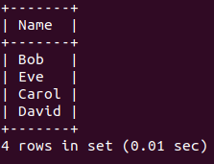

Aggregates, Group By, Having

Q6)
SELECT dept.DeptName, SUM(emp.Salary) AS TotalSalary
FROM Department dept
JOIN Employee emp ON dept.DeptID = emp.DeptID
GROUP BY dept.DeptName;

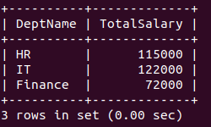

Q7)
SELECT dept.DeptName, SUM(emp.Salary) AS TotalSalary
FROM Department dept
JOIN Employee emp ON dept.DeptID = emp.DeptID
GROUP BY dept.DeptName
HAVING SUM(emp.Salary) > 100000;

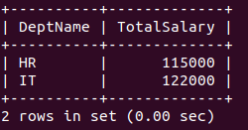

Q8)
SELECT proj.ProjectName, SUM(worksOn.HoursWorked) AS TotalHoursWorked
FROM Project proj
JOIN Works_On worksOn ON proj.ProjectID = worksOn.ProjectID
GROUP BY proj.ProjectName
HAVING SUM(worksOn.HoursWorked) > (
SELECT AVG(HoursWorked) FROM Works_On
);

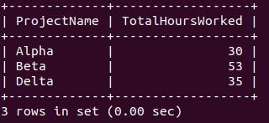

Q9)
SELECT dept.DeptName, AVG(emp.Salary) AS AvgSalary
FROM Department dept
JOIN Employee emp ON dept.DeptID = emp.DeptID
GROUP BY dept.DeptName
HAVING AVG(emp.Salary) > 60000;

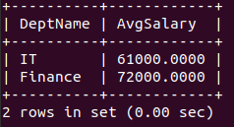

Q10)
SELECT dept.DeptName, AVG(emp.Salary) AS AvgSalary
FROM Department dept
JOIN Employee emp ON dept.DeptID = emp.DeptID
GROUP BY dept.DeptName
HAVING AVG(emp.Salary) > (
SELECT AVG(Salary) FROM Employee
);

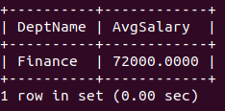

Q11)
SELECT emp.EmplD AS EmplID, emp.Name, proj.ProjectID, proj.Budget
FROM Employee emp
JOIN Works_On worksOn ON emp.EmplD = worksOn.EmplD
JOIN Project proj ON worksOn.ProjectID = proj.ProjectID
WHERE proj.Budget >= 700000 AND emp.Salary >= 70000;

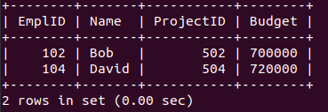

Q12)
SELECT emp.EmplD AS EmplID, emp.Name, worksOn.ProjectID, worksOn.HoursWorked
FROM Employee emp
JOIN Works_On worksOn ON emp.EmplD = worksOn.EmplD
WHERE worksOn.HoursWorked BETWEEN 28 AND 30;

